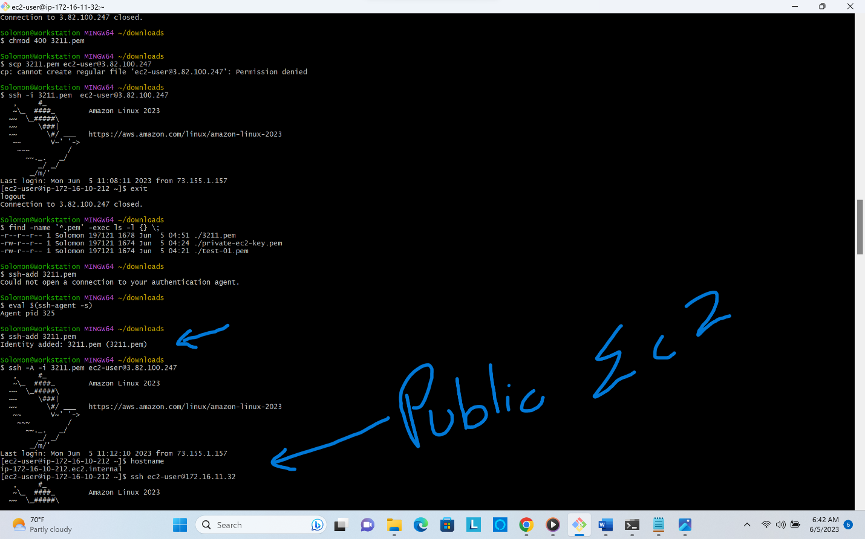

**adding .pem and entering into public ec2 server**

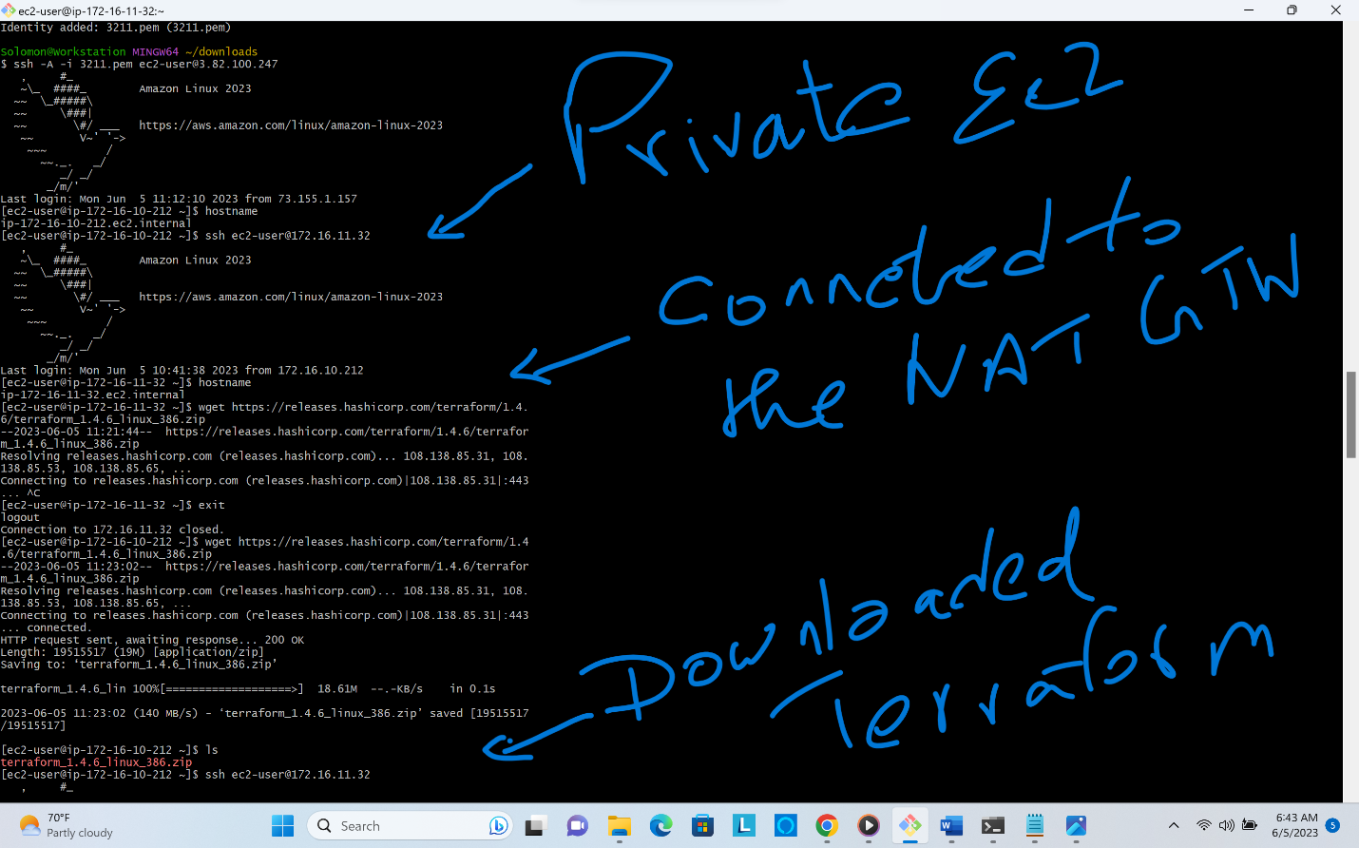

**Connected to the private ec2**

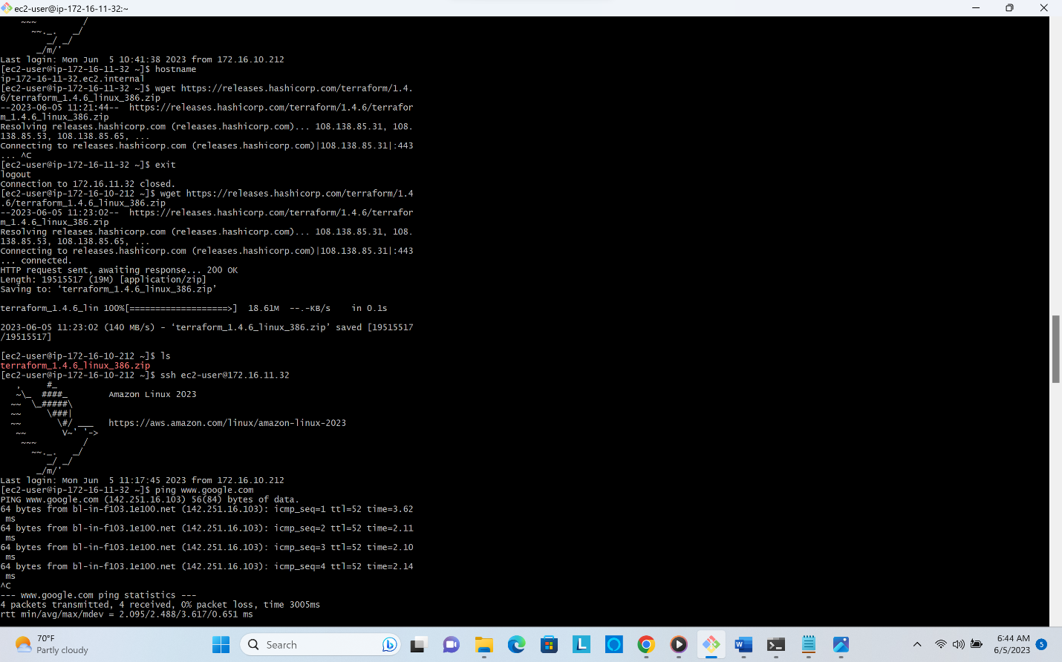

**Accessing internet on private instance through NAT**

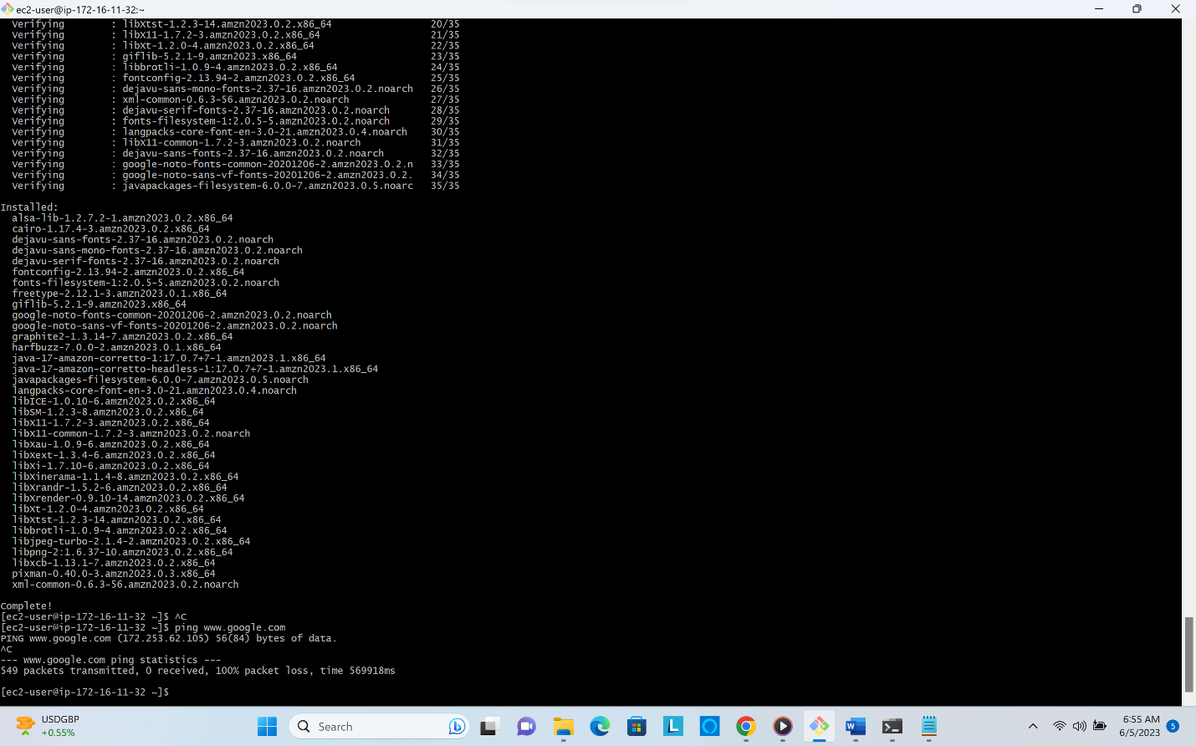**Connection couldn't get established after deleting the NAT (just for the demonstration)**

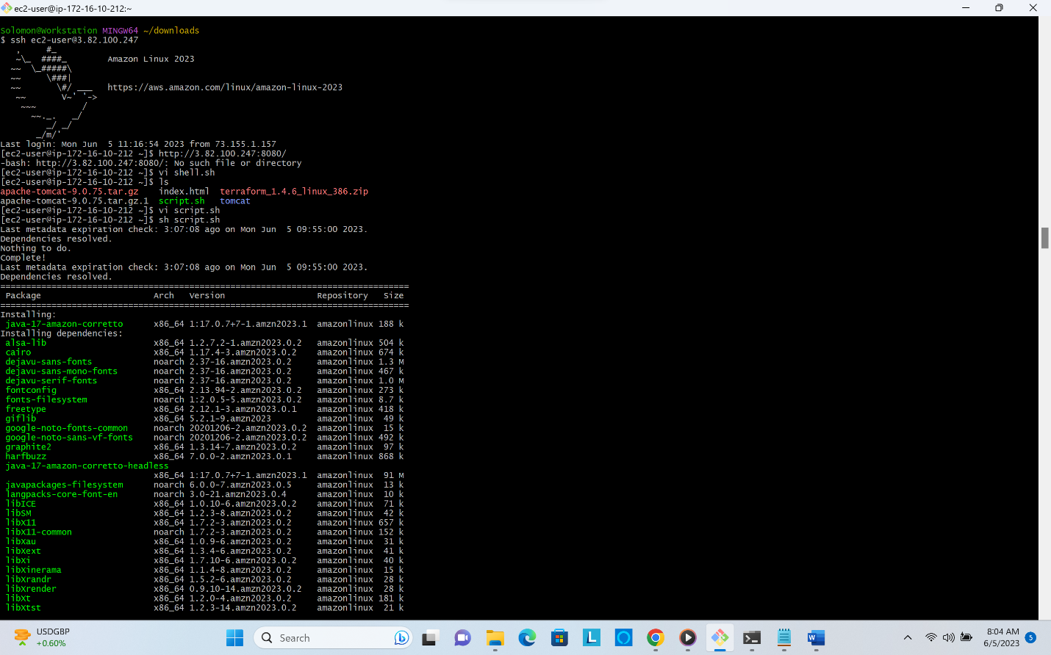**Executing the shell**

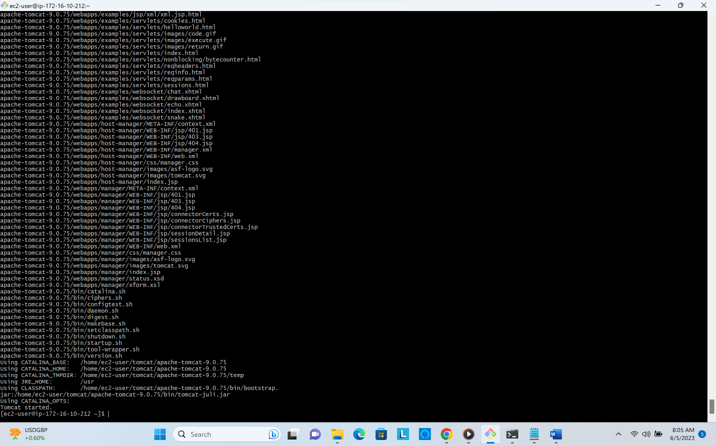**Tomcat Installed**

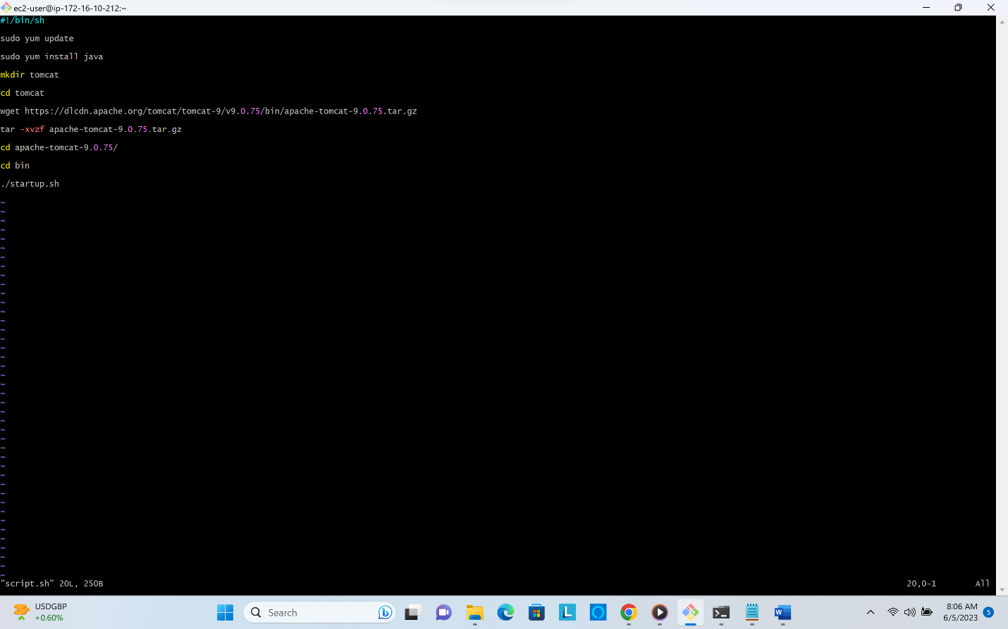**Shell script**

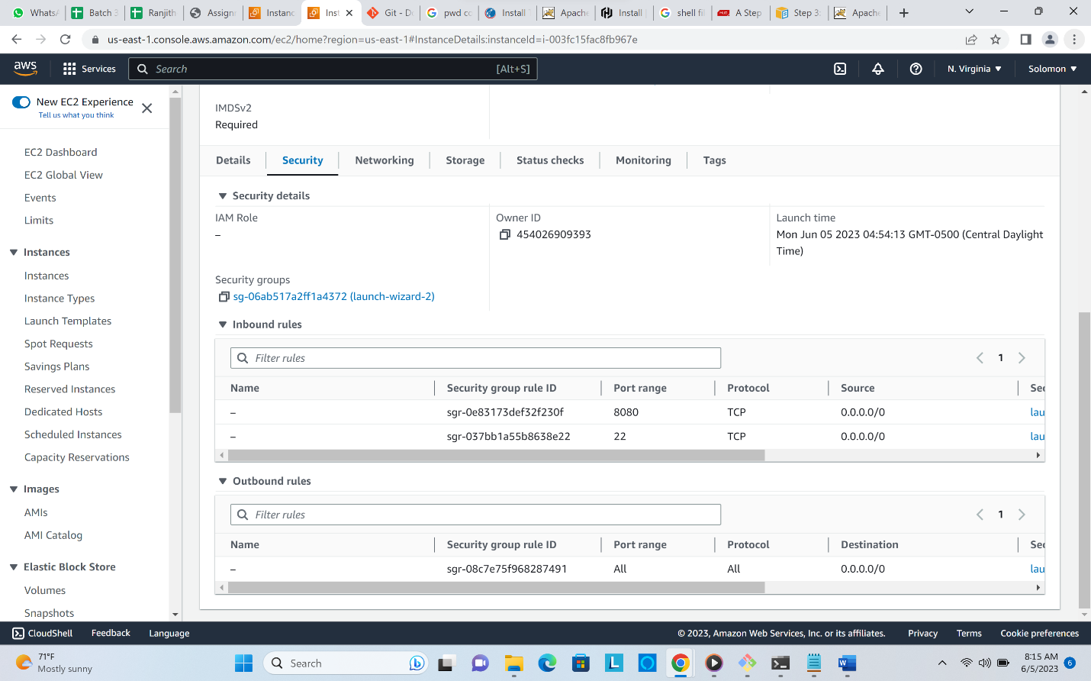**Updated EC2 Inbound rules**

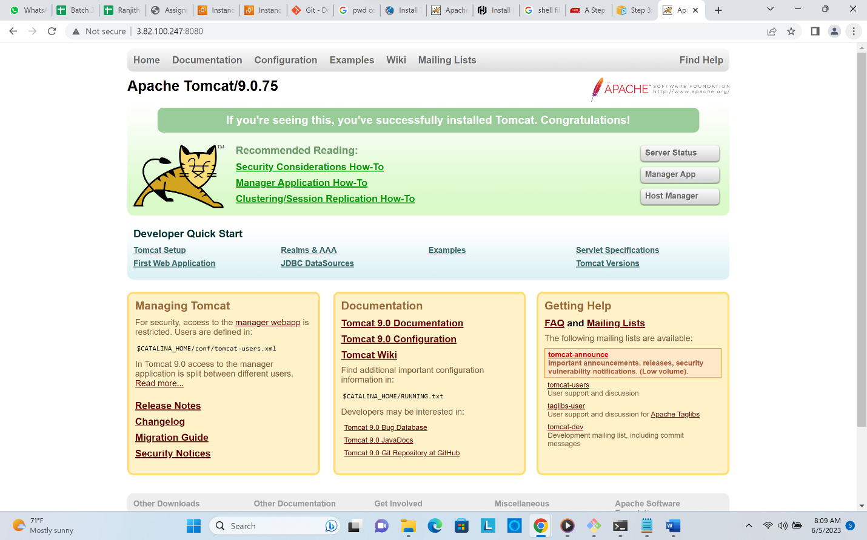Tomcat 9 on the browser, didn’t know how to automate that on the shell script, so manually opened the browser.